

Database Systems

Assignment 2

**Total Marks: 100**

**Due Date: 23 November 2024**

**Related topics: DDL, Basic DML**

**Instructions:**

1. Assignment must be submitted on portal in one word document
2. Late submission will cause you to lose 10% per day. After three days of deadline no submissions will be entertained.
3. Refrain from copying other student’s assignments. You will be awarded with zero marks in that case.

**Q1. Implement the given schema using DDL commands in SQL. Choose the appropriate action (restrict, cascade, set NULL, set default) for each referential integrity constraint, both for the deletion of a referenced tuple and for the update of a primary key attribute value in a referenced tuple. Give screen shots for all the commands with the SQL success message that the command has been executed successfully.** **(35 Marks = 7 tables X 5 marks each )**

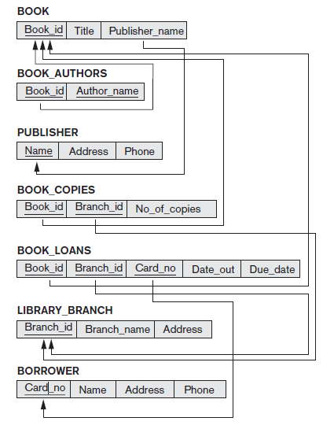

**Q2. Insert meaningful data in the specified tables (5 rows per table). While inserting this data if any problem occurs. Please state it with proper error message. Then also describe how you solved it to enter all the data.**

**Give screen shots for all the commands with the SQL success message that the command has been executed successfully. (15 Marks)**

**Q3. Execute the following queries on database that you created and give the screenshots of query and the result. (50 Marks = 5 Marks x 10 queries)**

1. Write a query to find books with more than 10 copies in a specific branch (e.g., Branch ID = 2) and published by a publisher located in "New York".

JOIN WALI QUERY AYE GE IDHR STUDY IT BROTHA ;)

1. Write a query to retrieve borrowers whose name starts with "A" or who have a phone number ending in "789".
2. Write a query to find all book loans where the loan's due date is between '2024-01-01' and '2024-03-01'.
3. Write a query to find books whose title contains the word "Programming".
4. Write a query to find publishers whose name does **not** start with the letter "M".
5. Write a query to list all borrowers sorted by their names in ascending order.
6. Write a query to retrieve the first 5 books (based on alphabetical order of their title).

Select Title

From BOOK

Order by Title

Limit 5;

================================ GOOD LUCK ================================